Cherokee Bowhunters
of Laurel Bloomery
will be hosting their Annual
Catch-A-Dream
Benefit Shoot & BBQ Fundraiser
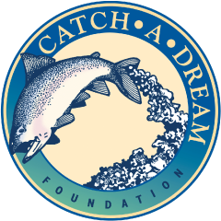

August 4th & 5^{h} from 8-3

This will be a 30 target 3-D Outdoor Archery shoot for all to come and enjoy.
We will be serving homemade BBQ with side dishes, snacks and drinks. Even if you don’t shoot, please come out and join us for some great fellowship and food.
For more info about the shoot, please call 423-727-1554 or go to www.shootarchery.com
All proceeds will go towards our goal to sponsor a child’s dream so all we ask is that you come and give from your heart to cover the cost of your entry fees and food. Any additional donations are appreciated.
For more info about Catch-A-Dream Foundation check them out at
www.catchadream.org

