The Lonesome Pine Soil & Water Conservation District presents:

“Kids in the Mountain”- Wildlife Education Program
Conservation Challenge 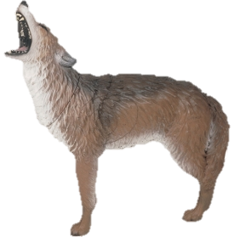 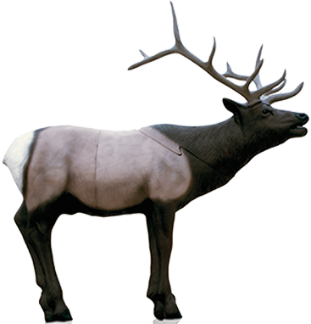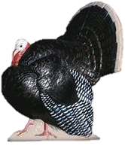
Family Archery Shoot
Classes for Kids, Teens, and Adults (Beginners to Advanced, Known & Unknown Yardage)
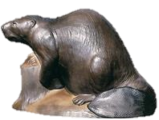
30- 3D Targets!!!
July 23rd
Registration Cost- FREE!!!
(Loaner Bows and Arrows available to Children without their own equipment on a limited basis)

No Crossbows or Broadheads Allowed & Children must be accompanied by an Adult

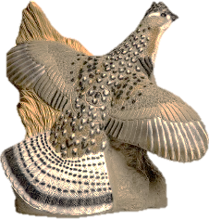
Location: 351 Flemingtown Drive, Clintwood, VA 24228
Registration: between 9am- 12noon
Directions: From Clintwood turn on Rt. 607 Clintwood Main St/The Lake Rd. Go 1 mile turn Right on Rt. 736 Flemingtown Drive. Go .25 miles sign on your left. For more information contact Landon Johnson (276) 926-6621

