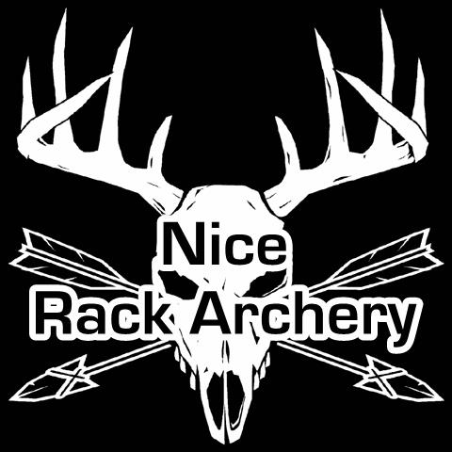

A Greeneville Elementary School teacher, Jeana Rollins Helton just found out she has an aggressive form of breast cancer. We are hoping to raise a little money to help defer the cost of treatments.
She will be undergoing 12 weeks of two types of chemotherapy followed by a double mastectomy, and 8 more weeks of very strong chemotherapy and radiation, then finally reconstructive surgery.
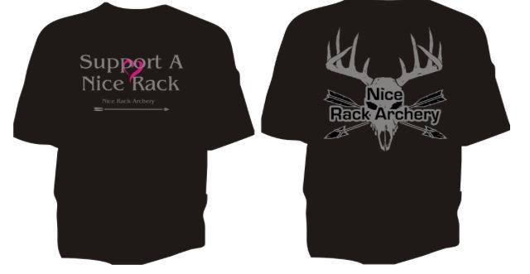
Sign up 8 am – 3pm
(One day shoot)
$10 per person
All age groups competing
Trophies awarded
Lunch and t-shirts available

$10.00
Add $2 for 2XL or larger…

