Nester’s Archery Shop
Indoor League
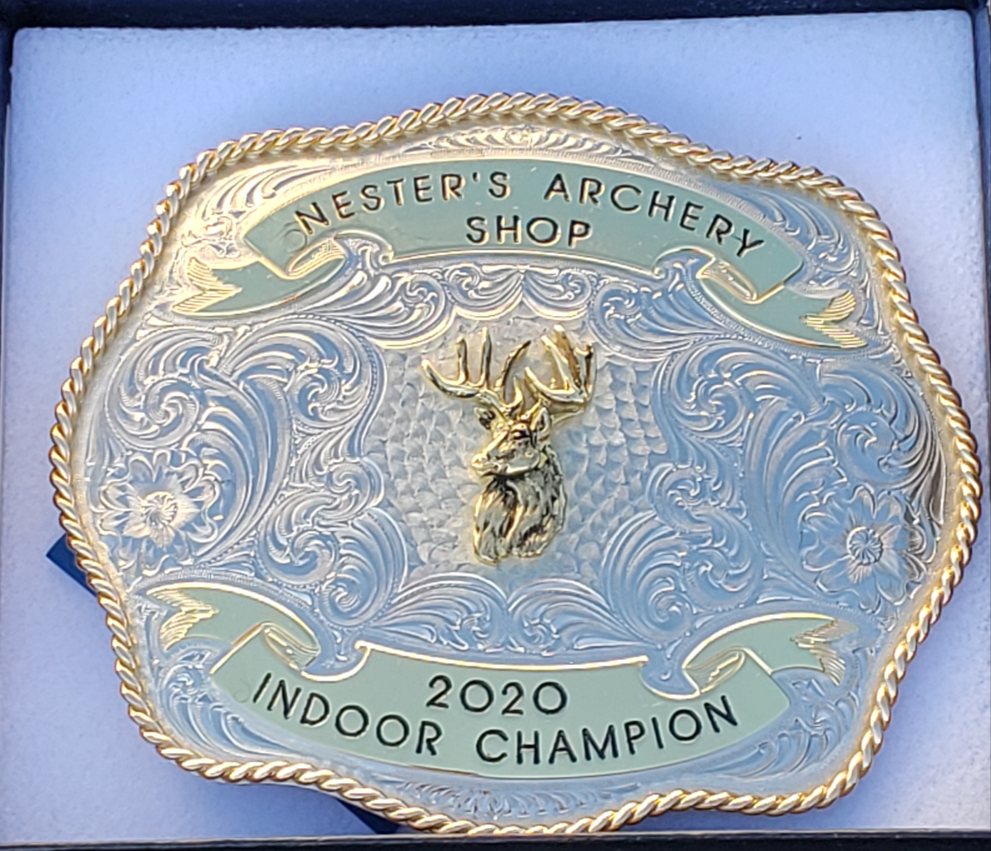
- 80% Handicap
- 2 person team (we can find a partner for you if needed)
- Pick one of the following nights
- Wed-Thurs-Friday 7PM (Practice starts at 6PM)
- Make up day Saturday 9:30AM (practice starts at 9AM).
- $10 a week must pay first half of the league prior to first night, must pay for second half prior to halfway mark, or you may pay all up front.
- 8- 12 week league depending on number of teams.
- Starts Wednesday December 11th. Will not shoot the week of Christmas.
- Lancaster style League
- Men, Women, and Kids are welcome.
- Must be signed up by Dec 7th to make sure we can accommodate for the night you choose to shoot.

Address: 6085 Fancy Gap Hwy Hillsville VA 24343
Shop Number: 276-728-0009

