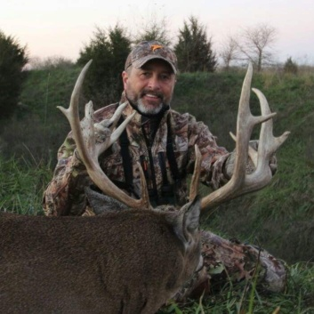
Pisgah Archery

Sunday, August 28th

^{Casual Registration from 8-2}
Classes
Men’s Pro Women’s Pro Young Adult
Men’s K-50 Women’s K-40 Youth
Men’s K-40 Women’s Hunter Cubs
Men’s Hunter Seniors Traditional

Shoot for DONATIONS

ALL proceeds will go to the McCall Family

For those of you who know Bill, you know he’s a great father, husband, archer, friend, colleague, hunter, and most of all a great man of God. Please come out to this event and help support the McCall Family. Bill fell over 40 feet out of a tree while working his day job. He is currently in ICU suffering several broken ribs, a punctured lung, and a bruised brain. Bill has been in the archery community for several years and does his part in helping the community, now it is time for the community to help his family.

