SMA/MAC Indoor Championship
Morristown Archery Club
Jan 10. 7 P.M.
Feb 14. 4 P.M. / 7 P.M.
Mar 7. 4 P.M. / 7 P.M.
Smoky Mountain Archery
Jan 24. 7 P.M.
Feb 28. 4 P.M. / 7 P.M.
Mar 14. 4 P.M. / 7 P.M.
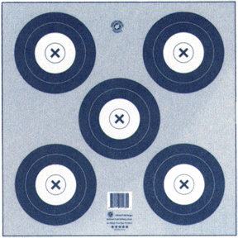
Classes
Open Money- $20 Per Shoot (6 shoots, Can drop 1 of the first 5, Last tournament is scored as championship.) (100% Payback at Championship for all 6 Shoots)
Trophy Classes- $25 Gift cards will be awarded at next shoot by:
Sportsman Choice & Toms Sporting Goods. (Must be at least 3 shooters in Class)
Men’s Open
Men’s Hunter
Women’s Open
Women’s Hunter

