STAUNTON RIVER
ARCHERY CLUB
15725 Rockford School Rd. Hurt, VA 24563
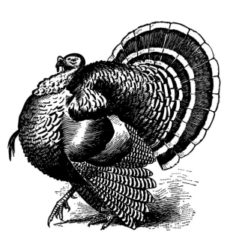
2015 SHOOT SCHEDULE
JANUARY: 17 18
FEBURARY: 28, March 1
MARCH: 14 15 *ASA Qualifier*
MAY: 16 17
JUNE: 20 21 *ASA Qualifier*
JULY: 18 19
AUGUST: 29 30
SEPTEMBER 26 27 (First Annual Joe McManus Memorial Shoot) (VBA Hunter Round) (No 3-D)
SH00T TIME: 8AM TO 2PM, SCORES ARE POSTED ON WWW.SHOOTARCHERY.COM
* All SHOOTS WILL FOLLOW ASA RULES *
OFFICERS
PRESIDENT: IAN RIGNEY – (434)546-3605
VICE PRESIDENT: STEVE SHEILDS - (540)494-9316
PERRY GAUZE – (434)441-6747

