STAUNTON RIVER
ARCHERY CLUB
15725 Rockford School Rd. Hurt, VA 24563
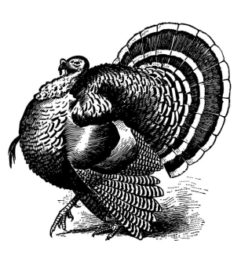
2018 SHOOT SCHEDULE
JANUARY: 6-7
FEBURARY: 10-11
MARCH: 10-11 *ASA State Qualifier*
April: 7-8
MAY: 12
JUNE: 23-24 *ASA State Qualifier*
JULY: 21-22
AUGUST: 11-12
SEPTEMBER 29-30 (Fourth Annual Joe McManus Memorial Shoot) (VBA Animal Round) (No 3-D)
SH00T TIME: 8AM TO 2PM, SCORES ARE POSTED ON WWW.SHOOTARCHERY.COM
* All SHOOTS WILL FOLLOW ASA/VBA RULES *
OFFICERS
PRESIDENT: PAUL JOHNSON – (434)401-0798
VICE PRESIDENT: STEVE SHIELDS - (540)520-0349

