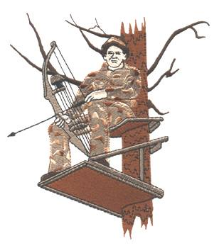

## 3D Range

**$ 15 Fun Rounds Compound and Traditional**

**$25 Money Classes Compound and Traditional**

**$30 Maximum rate for Family**

**(Lunch is included in Registration)**

**Pop-ups**

**(as seen on TV)**

**$5 Fun rounds Compound and Traditional**

**$10 Money rounds Compound and Traditional**

**Pay backs**

**$10 per shooter in 3D**

**$5 per shooter in pop ups**

**Pay backs will be paid daily for pop ups**

**For more information call**

**Richard Shields: 336-337-5028**

**Gary Clark: 336-207-3276**

**Guy Hutcherson: 336-306-3512**

Lunch will be Big Buck chickin and taters ☺

9

# TAA Bow Hunter Jamboree

### 8/18 & 8/19

## 20 Compound 3D Targets

## 10 Traditional only Targets

**(Shoot twice for a total of 20 Targets)**

**@ stick and wheel archery club**

**Registration from 9 till 3 on Saturday**

**From 9 till 2 sunday**